Week 4(Model API)

Name: Uthej Goud

Batch Code: LISUM01

Submission date: 3/7/2021

Submitted to: Data Glacier

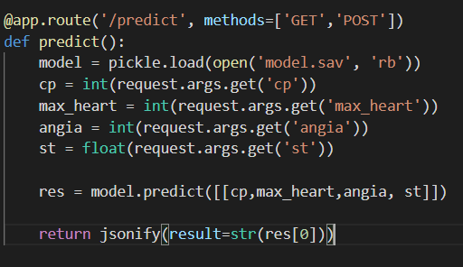

New url to serve API requests

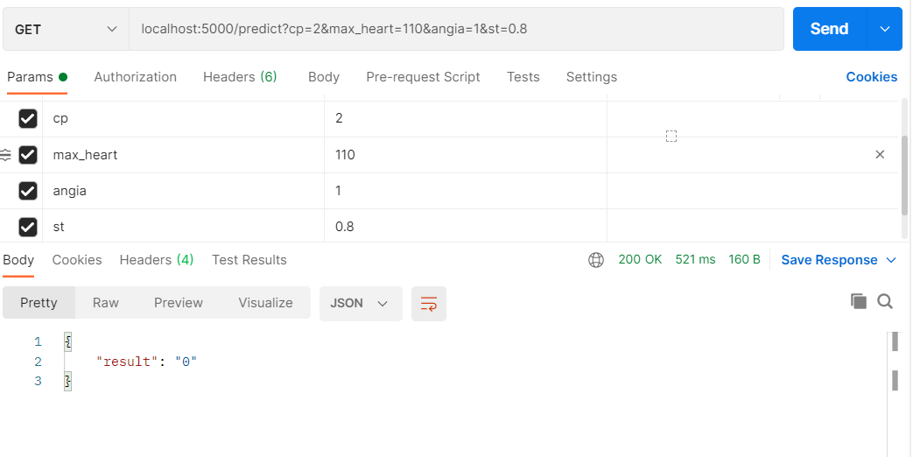

Working API request